**Intermediate Algebra Name: _____________________________**

**Graphing Inequalities Worksheet Hour: _______**

**Graph each inequality . Make sure to use appropriate dotted or solid line and shade correct region.**

1.  2. 

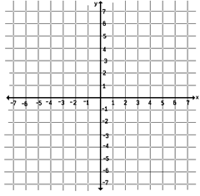

**3. 4.**

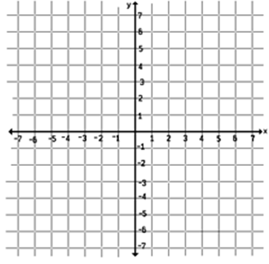

5. 6.

7. 8.

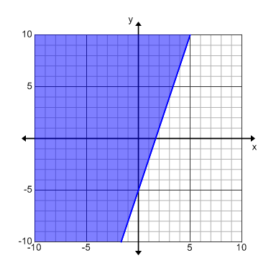In 9 - 12, Fill in the blank with the appropriate inequality sign.

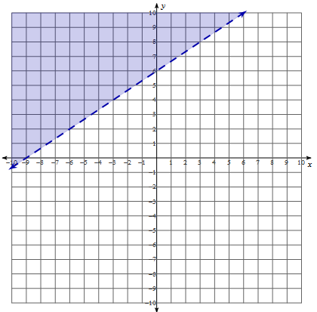9. 10.

Inequality: y 3x - 5 Inequality: 3y – 2x 18

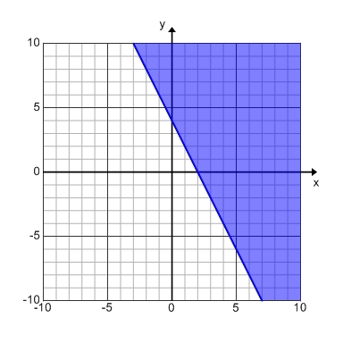

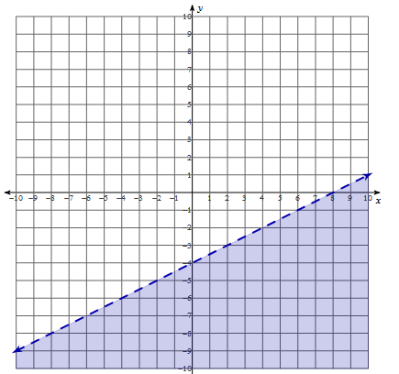11. 12.

Inequality: y $\frac{1}{2}x-4$ Inequality: 2x + y 4